Bahan-bahan:

1. CodeIgniter versi 3.x : https://www.codeigniter.com/download
2. Rest Template : <https://github.com/chriskacerguis/codeigniter-restserver>, berbasis bahasa pemrograman PHP menggunakan framework codeigniter
3. XAMPP dengan PHP versi >= 5.4
4. Retrofit : <https://square.github.io/retrofit/>, Library android untuk menangani HTTP
5. Browser Chrome+Postman : <https://chrome.google.com/webstore/detail/postman/fhbjgbiflinjbdggehcddcbncdddomop>, untuk melakukan test pada API

**Membuat API**

1. Download codeigniter 3.x dan extract di xampp/htdocs,rename menjadi ‘registration’
2. Download ci rest template:

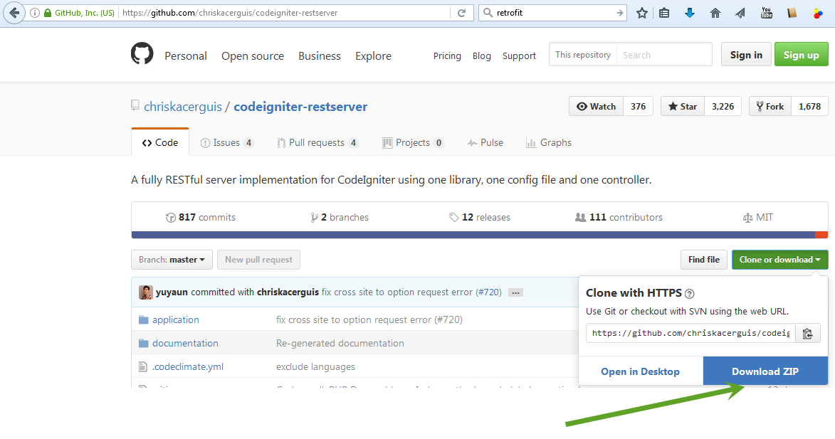

Lakukan ini:

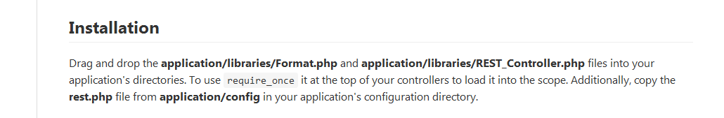

File Format.php,REST_Controller.php dan rest.php tersebut dari folder codeigniter rest server yang di download diatas.Copy dari codeigniter rest server ke folder registration:

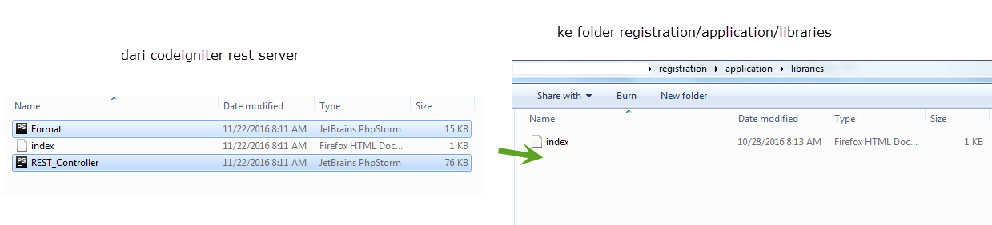

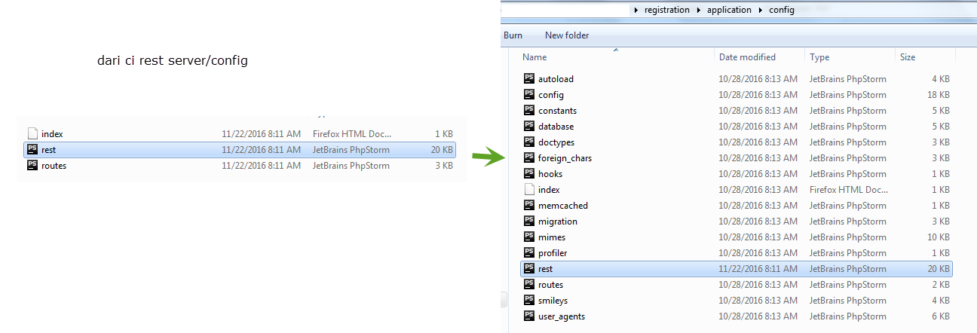

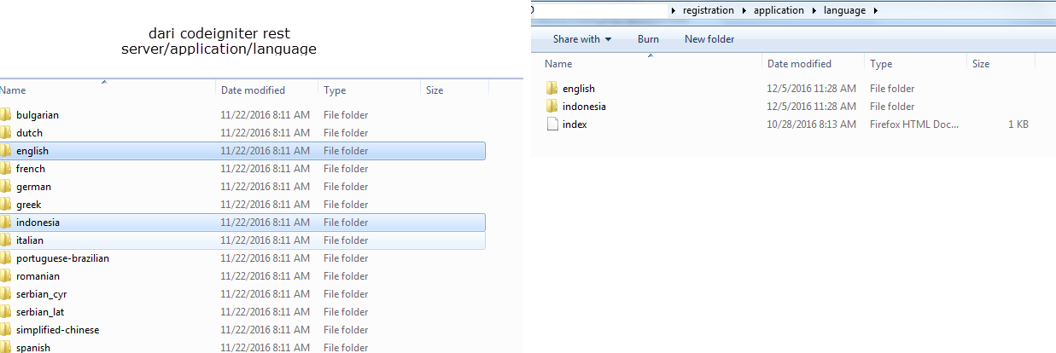

1. Buat folder api di registration/application/controller:

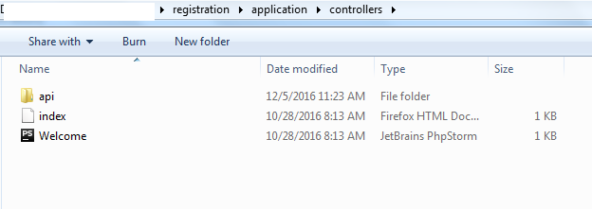

Buat file Member.php di folder api :

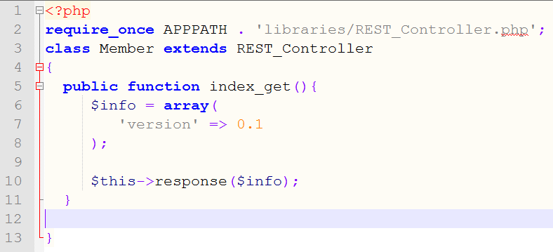

Untuk melakukan test,maka gunakan Postman yang telah di install di Chrome:

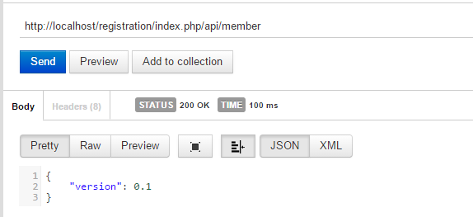

Output tersebut adala JSON.Silahkan cari referensi tentang JSON.

1. Membuat database dan tabel:

Buat database : appregister dan sebuah tabel:

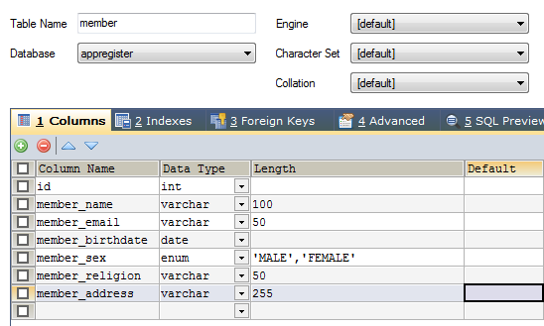

Jangan lupa config database di codeigniternya:

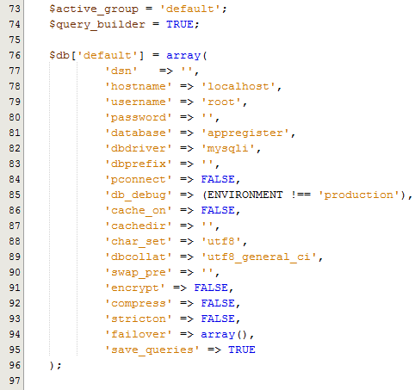

1. Membuat model:

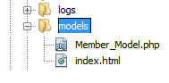

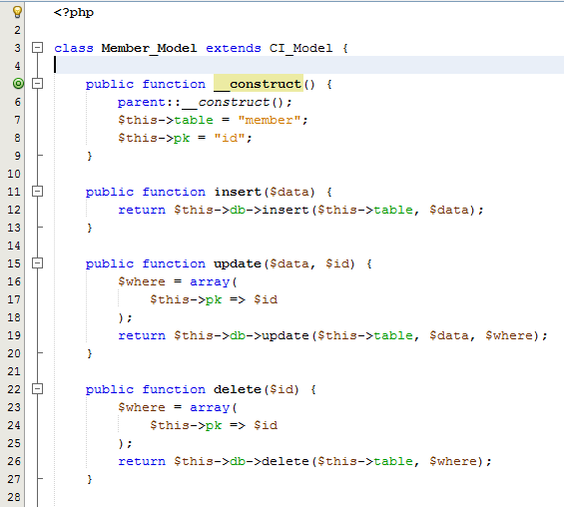

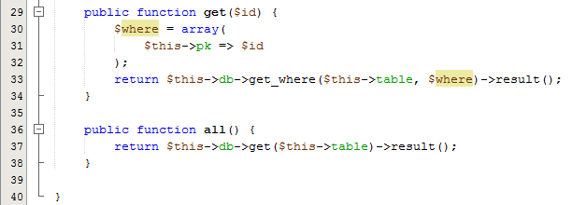

1. Membuat controller

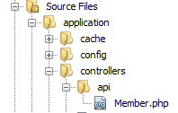

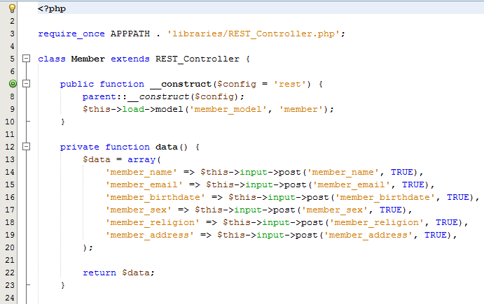

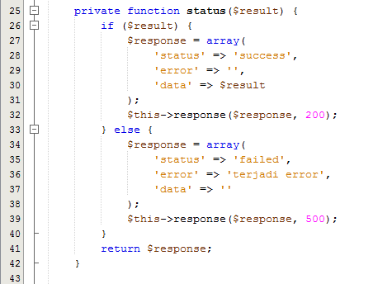

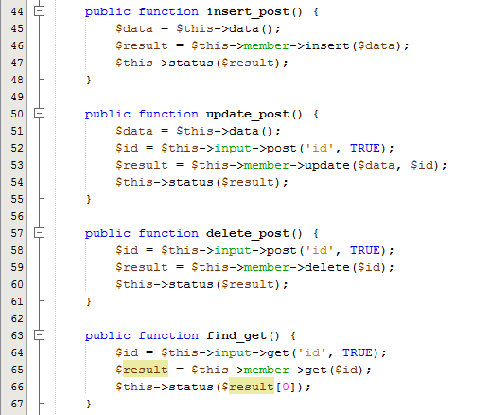

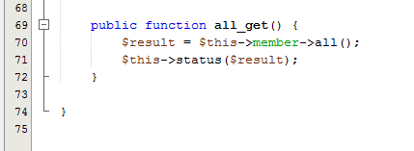

1. Melakukan test di Postman

Test insert:

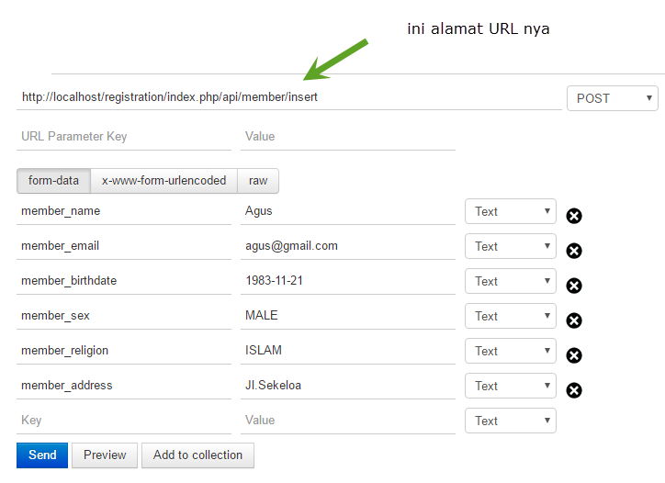

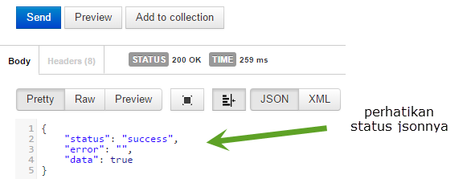

Hasil di database:



Test Edit:

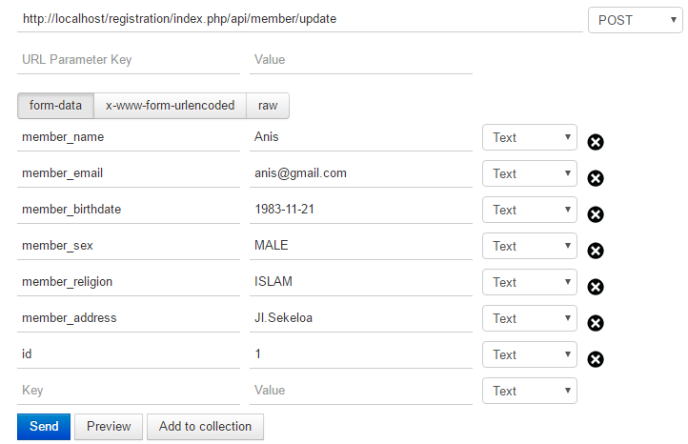

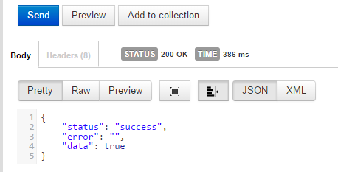

Test mendapatkan data dari id : (find)

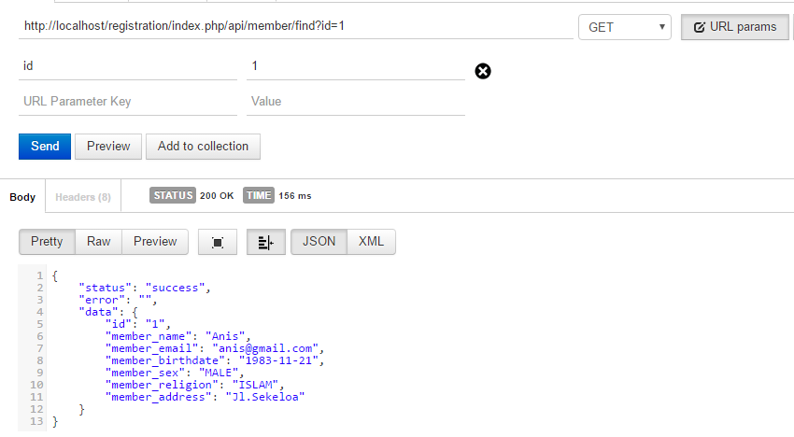

Mendapatkan semua data:

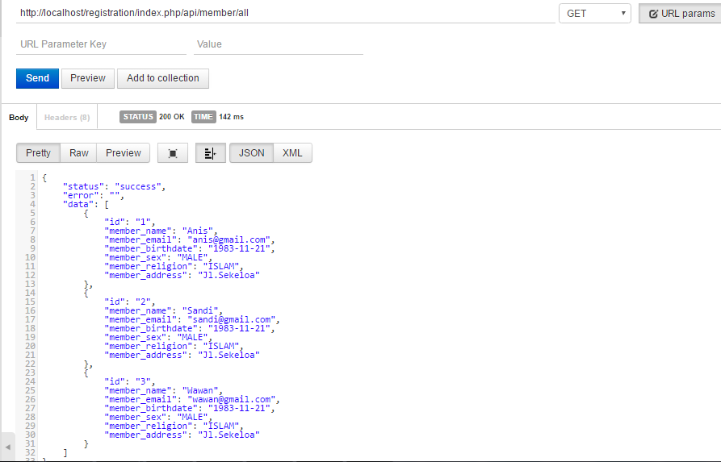

**Perhatikan Alamat** [**http://dst**](http://dst)**...., itu adalah alamat dari REST yang akan dipanggil oleh Android.Jika dihosting maka sesuaikan alamatnya.**

**Android Dan HTTP**

Menggunakan Retrofit : <https://square.github.io/retrofit/>

Tutorial menggunakan Retrofit : <http://www.twoh.co/2016/05/tutorial-belajar-menggunakan-retrofit-2-di-android-http-get-basic/>

1. Buat project baru : AppMember, pilih Empty Activity kemudian classnya : MainActivity

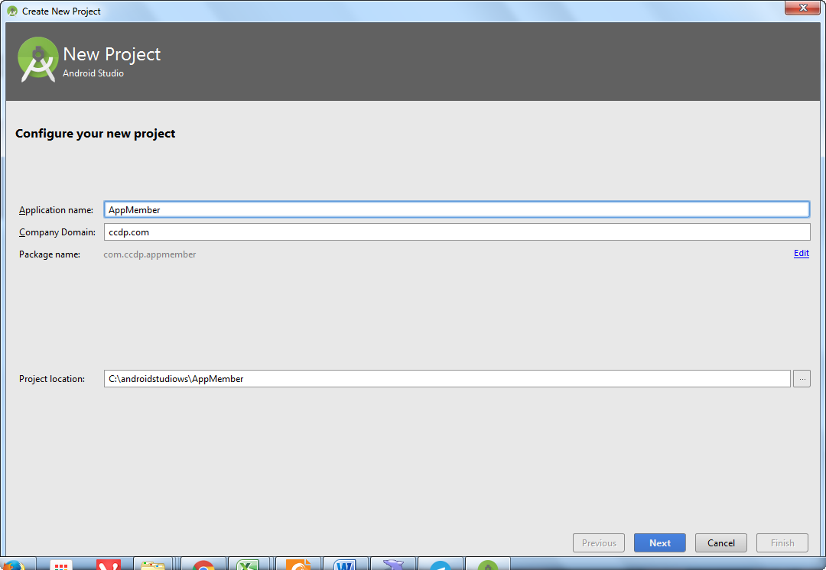

1. Menambahkan library Retrofit dan GSon :

compile **'com.google.code.gson:gson:2.6.2'**compile **'com.squareup.retrofit2:retrofit:2.0.2'**compile **'com.squareup.retrofit2:converter-gson:2.0.2'**

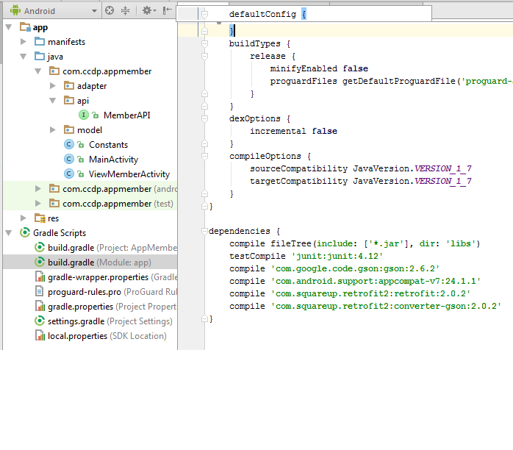

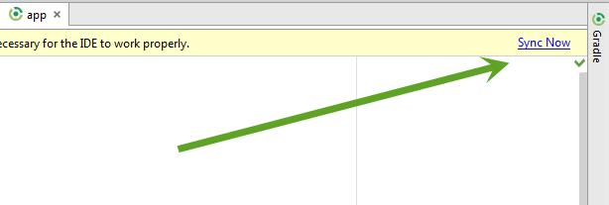

Biarkan sampai build selesai.

1. Struktur Package

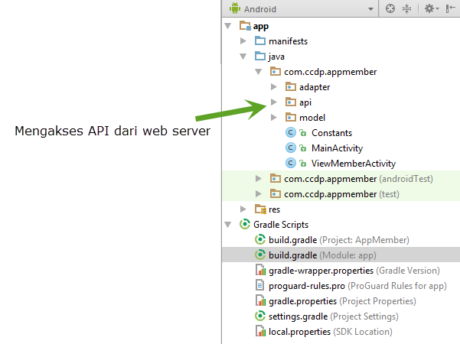

1. Package com.ccdp.appmember.model

Buat class Java:

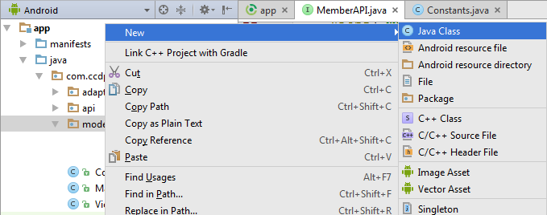

Member.java

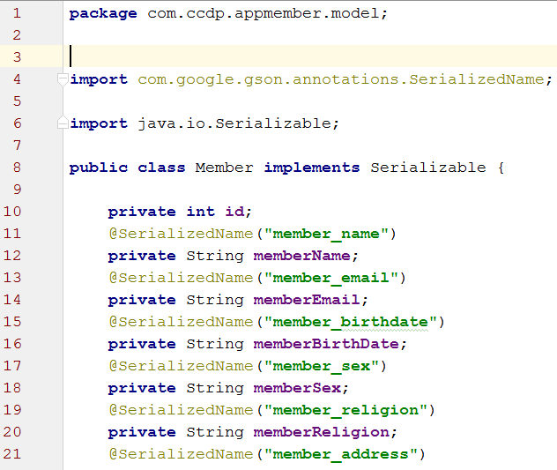

Buat constructor kosong (default constructor,generate constructor,set dan get,equals dan hashcode).

Buat Java Class : MemberResults.java

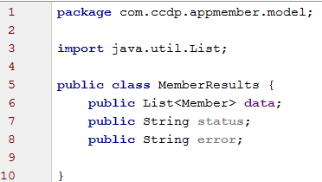

1. Package com.ccdp.appmember.api

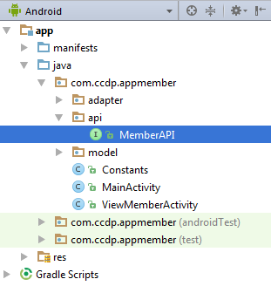

Buat class Java:

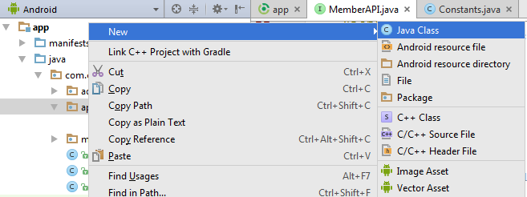

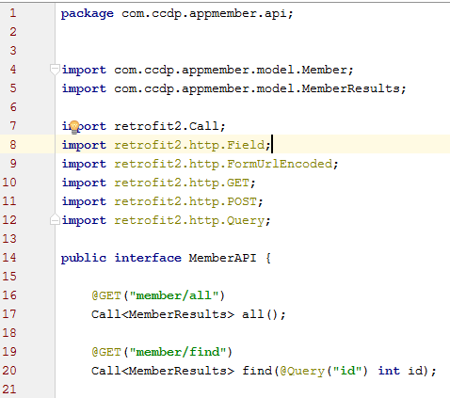

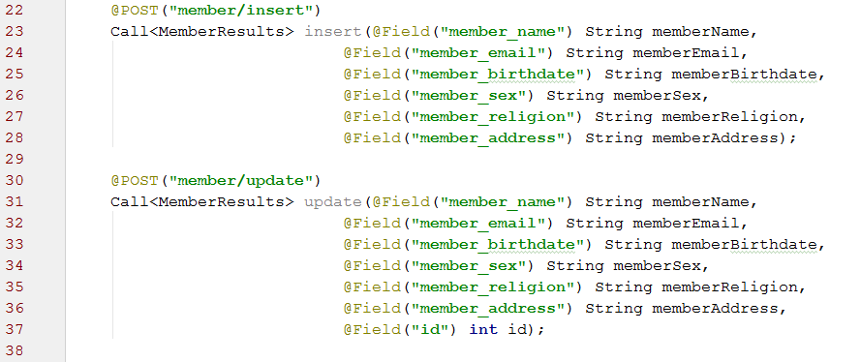

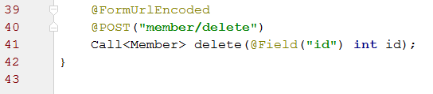

1. Layout activity_main.xml

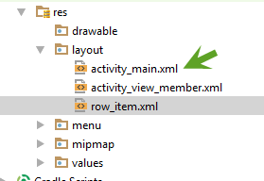

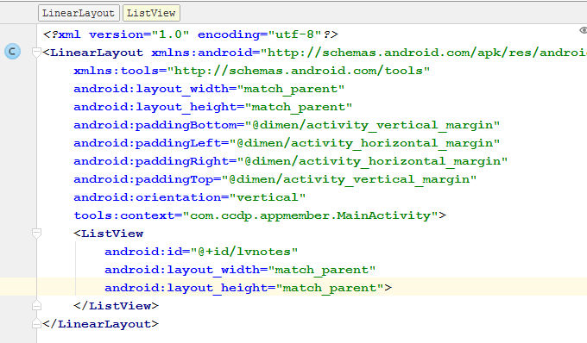

1. Layout : row_item.xml

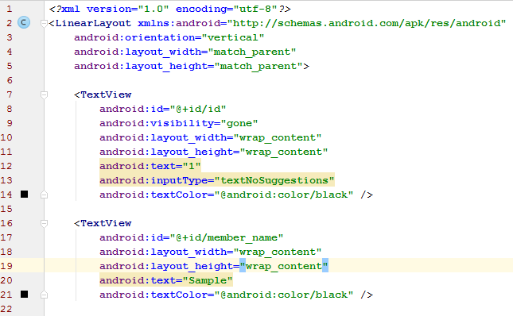

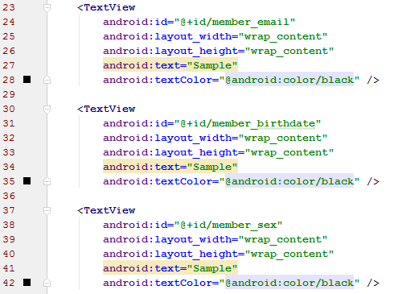

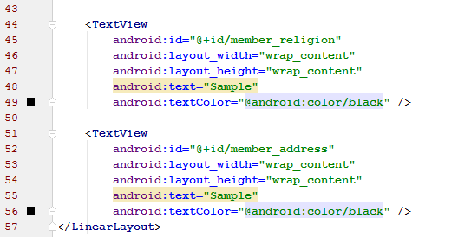

1. Adapter:

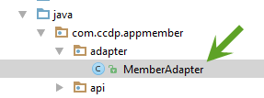

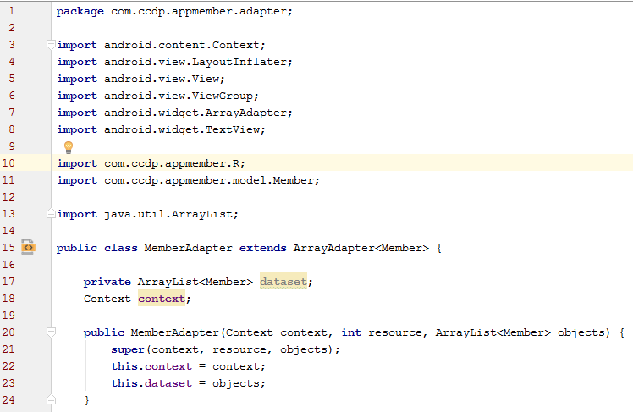

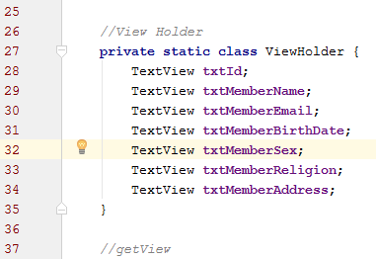

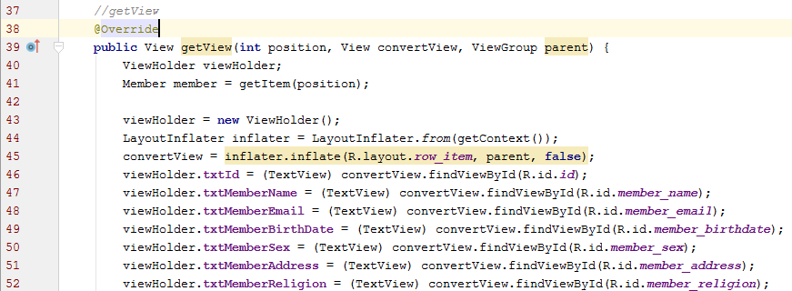

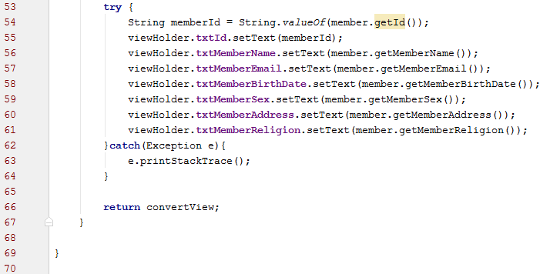

1. MainActivity.java

**package** com.ccdp.appmember;  
  
**import** android.content.Intent;  
**import** android.os.Bundle;  
**import** android.support.v7.app.AppCompatActivity;  
**import** android.view.Menu;  
**import** android.view.MenuItem;  
**import** android.view.View;  
**import** android.widget.AdapterView;  
**import** android.widget.ListView;  
**import** android.widget.Toast;  
  
**import** com.ccdp.appmember.adapter.MemberAdapter;  
**import** com.ccdp.appmember.api.MemberAPI;  
**import** com.ccdp.appmember.model.Member;  
**import** com.ccdp.appmember.model.MemberResults;  
  
**import** java.util.ArrayList;  
**import** java.util.List;  
  
**import** retrofit2.Call;  
**import** retrofit2.Callback;  
**import** retrofit2.Response;  
**import** retrofit2.Retrofit;  
**import** retrofit2.converter.gson.GsonConverterFactory;  
  
**public class** MainActivity **extends** AppCompatActivity {  
  
 **private** ListView **listView**;  
 **private** ArrayList<Member> **members**;  
 **private static** MemberAdapter *adapter*;  
 Retrofit **retrofit**;  
 MemberAPI **memberAPI**;  
  
 @Override  
 **protected void** onCreate(Bundle savedInstanceState) {  
 **super**.onCreate(savedInstanceState);  
 setContentView(R.layout.***activity_main***);  
 **listView** = (ListView)findViewById(R.id.***lvnotes***);  
  
 **retrofit** = **new** Retrofit.Builder()  
 .baseUrl(Constants.***ENDPOINT***)  
 .addConverterFactory(GsonConverterFactory.*create*())  
 .build();  
  
 **memberAPI** = **retrofit**.create(MemberAPI.**class**);  
 Call<MemberResults> call = **memberAPI**.all();  
 call.enqueue(**new** Callback<MemberResults>() {  
 @Override  
 **public void** onResponse(Call<MemberResults> call, Response<MemberResults> response) {  
 **try** {  
 **members**.clear();  
 MemberResults results = response.body();  
 List<Member> mems = results.**data**;  
 **for**(Member m : mems){  
 **members**.add(m);  
 }  
 *adapter*.notifyDataSetChanged();  
 }**catch** (Exception e){  
 Toast.makeText(MainActivity.**this**,e.getMessage(),Toast.***LENGTH_SHORT***).show();  
 }  
 }  
  
 @Override  
 **public void** onFailure(Call<MemberResults> call, Throwable t) {  
 Toast.makeText(MainActivity.**this**,t.getMessage(),Toast.***LENGTH_SHORT***).show();  
 }  
 });  
  
 **if**(**members** == **null**){  
 **members** = **new** ArrayList<>();  
 }  
  
 *adapter*= **new** MemberAdapter(getApplicationContext(),R.layout.***row_item***,**members**);  
 **listView**.setAdapter(*adapter*);  
  
 **listView**.setOnItemClickListener(**new** AdapterView.OnItemClickListener() {  
 @Override  
 **public void** onItemClick(AdapterView<?> adapterView, View view, **int** position, **long** l) {  
 Member member = **members**.get(position);  
 Intent intent = **new** Intent(MainActivity.**this**,ViewMemberActivity.**class**);  
 intent.putExtra(**"id"**,member.getId());  
 startActivity(intent);  
 }  
 });  
 }  
  
 @Override  
 **public boolean** onCreateOptionsMenu(Menu menu) {  
 getMenuInflater().inflate(R.menu.***menu_main***, menu);  
 **return true**;  
 }  
  
 @Override  
 **public boolean** onOptionsItemSelected(MenuItem item) {  
 **int** id = item.getItemId();  
  
 **switch** (id){  
 **case** R.id.***action_add***:  
 **break**;  
  
 **case** R.id.***action_exit***:  
 finish();  
 **break**;  
 }  
  
 **return super**.onOptionsItemSelected(item);  
 }  
  
  
}

(**Bersambung**)

1. Fsd